DYNAMIC EVALUATION OF BALANCED SCORECARD USING FUZZY KNOWLEDGE BASED REPRESENTATION

Felisa M. Cordova,
Department of Industrial Engineering, University of Santiago of Chile, USACH
Ecuador 3769, Estacion Central, Santiago, Chile
felisa.cordova@usach.cl

ABSTRACT
This paper presents a model that allows the dynamic evaluation of the Balanced Scorecard (BSC) using fuzzy knowledge based representation of concepts, variables and their relationships expressed through vectors and membership functions. BSC translates business vision and mission in a set of actions which are guided by strategies. A strategic map, translated into a conceptual map of fuzzy relationship, represents a set of objectives and indicators which are triggered by causal relationships between them providing a framework for management, coordination and control appropriate to the business development. The experts who participate in the workshops of BSC development normally use fuzzy linguistic approaches. The proposed model incorporates fuzzy knowledge representation and fuzzy knowledge matrix manipulation mechanisms to assess dynamic factors on each axis of the BSC and the impact of the factors between the different axes of the proposed strategic map. Confidence intervals are defined to capture expert opinion. A set of Fuzzy Incidence Matrix called Direct Impact Matrix is defined for collaborating in the validation of the relationship causal link between objectives and indicators. Also, any indirect incidence factor between the critical success factors may be identified, on the relationship causal link between variables.

Keyword: Strategy, Balanced Scorecard, Fuzzy Knowledge Representation, Incidence Matrix.

INTRODUCTION

The Balanced Scorecard (BSC) has proved to be a powerful management tool that allows connecting current actions with future strategic objectives considering measures based on indicators and inductors (Kaplan et al., 1996), (Kaplan et al., 2003). The BSC translates business vision and mission into a set of actions which are guided by strategies. A set of objectives and indicators which are triggered by causal relationships between them is generated and it is represented through a strategic map, in order to provide a framework for management, coordination and control appropriate to the business development (Kaplan et al., 2000). The model used by the BSC finally allows the identification of the factors that create long-term economic value in an organization (Kaplan et al., 2006). Both the indicators of outcome measures and the inductors of results called performance drivers respond to cause and effect relationships and they allow checking the success or failure of the strategy used (Kaplan et al., 1996), (Kaplan et al., 2000). Nevertheless, this approach does not consider existing dynamics between BSC axes; order and priority of the connection between axes; degrees of influence between axes; particular state of each axis and state of the system on the basis of the combination of the diverse states of the axes (Cordova et al., 2010). On the other hand, the experts who participate in BSC development workshops normally use fuzzy language approaches to express the variables and their relationships, such as "high market share” or "poor customer service" (Silder et al., 2005). In this context it is necessary to incorporate fuzzy knowledge representation and fuzzy knowledge matrix manipulation mechanisms to assess dynamic factors on each axis of the BSC and the impact of the factors between the different axes of the proposed strategic map (Kaplan et al., 2004), (Zadeh, 1985). The variables are expressed through vectors and membership functions. Also, language tags are defined that allow the expression and evaluation of definitions and fuzzy concepts, and the set of variables defined in the strategy map translates into a conceptual map of fuzzy relation (Cordova et al., 2008). In the evaluation of each variable it is possible to establish a measure of the gap with the objective, which is expressed by the distance between the language tag and the desired state of the variable. Confidence intervals are defined to capture expert opinion, and they can be applied after the variables or the critical success factors have been evaluated from every perspective: financial, customer, process, and learning and growth (Kaplan et al, 2004). A Fuzzy Incidence Matrix set is defined with the aim of collaborating in the validation of the causal relationship link between objectives and indicators. The incidence network of the critical success factors can also help to identify through the Direct Impact Matrix the importance of each of the variables involved in the model (Cordova et al., 2010). It is also possible to identify any indirect incidence factor between the critical success factors on the causal relationship link between variables. A heuristic identifies the causes that act as intermediaries on the effects that were not taken into account in the initial strategic map definitions.

CAUSE-EFECT RELATIONS AND IMPRECISE DEFINITIONS USED IN THE METHODOLOGY OF THE BSC
In the BSC outcome measures are combined with factors that will have an influence on future results, the so-called performance drivers. These measures respond to cause and effect relations and allow confirming the success or failure of the strategy used. For example, a growth strategy oriented at increasing the client’s value through a value proposal for him implies focusing on the client, who implies activating processes to satisfy retain and acquire clients in meta segments, but it also requires providing innovative products and services and adequate after-sales support. In turn, all this must be reinforced with organizational learning and growth that allow the training and know-how of people to favor innovation in products and/or services. It is therefore necessary to know, understand and interpret adequately the cause-effect relations on which the strategy is built, as well as the crossing of the associated processes.
On the other hand, the different experts who participate in the BSC preparation workshops deliver approximations of the variables used and their relations, which are incorporated in the conceptual relations map. These definitions are not always precise, and when expressed linguistically they can introduce imprecision such as: there is a “deficient customer service”, or “we have a high market share”. In any case, these qualitative expressions must be represented quantitatively in some way to work with them. Besides, the fact of surmising or not a positive or negative correlation between critical success factors does not always imply that a factor is the cause of another one. Furthermore, in the case of indirect correlations between factors, it will be the expert who will reevaluate this situation.

FUZZY LOGIC IN THE DEFINITION OF VARIABLES, LANGUAGE TAGS, AND CONFIDENCE FACTORS IN THE BSC
Fuzzy Logic provides different approaches and tools that give rise to the expression of imprecision in the language used by the experts and specialists in the definition of important variables associated with strategic objectives:
a) Use of membership functions.
Let X be a classical set of objects, called the universe. Belonging to a subset A of x can be defined in terms of the characteristic function:

μ_{A}: X ⎯⎯⎯⎯⎯⎯⎯⎯→ {0, 1}

x ⎯⎯⎯⎯⎯⎯⎯⎯⎯→ μ_{A}(x)

1, x ∈ A
where μ_{A}(x) =
0, x ∉ A.

If the evaluation set {0,1} is extended to the real interval [0,1], it is possible to talk about the partial belonging in A, where μ_{A}(x) is the degree of belonging of x in A, and the values 0 and 1 are interpreted as "non-belonging" and "total belonging", respectively. Clearly, A is a subset of x, which has no defined boundaries. This leads to the following definition:

Let X be an object's space. A fuzzy set A of X is characterized by the set of pairs:

A = {(x,μ_{A}(x)) / x ε X}, where μ_{A} : X [0,1]

The fuzzy concept proposed (Zadeh et al., 1975) is based on the fact of allowing the partial belonging in a set for certain elements of a given universe.

b) Use of language variables to represent concepts.
In the case of the language variable “client satisfaction”, the fuzzy sets associated with the definitions of “very unsatisfied”, “satisfied”, “very satisfied” can be defined as shown in Figure 1. There are then three membership functions (x) that define the degree of belonging to the client sets very unsatisfied, satisfied, and very satisfied. The following equation represents the triangular membership function corresponding to “satisfied”:

0, x ≤ a

x – a, a ≤ x ≤ b
b - a

µ (x; a, b, c) = c – x, b ≤ x ≤ c
c – b

0, c ≤ x

Very unsatisfied client
1 --
µ (x)
Satisfaced client
Very satisfaced client

0.5 - --

0 25 a 50 b 75 c 100 X
Figure 1: Language variable for modeling client satisfaction.

The client satisfaction variable can then be expressed by a vector that has three components expressed by three membership functions for “very unsatisfied”, “satisfied”, “very satisfied”. In the following cases, a very unsatisfied client, a satisfied client, or a very satisfied client can be defined linguistically by means of the following vectors:

Very unsatisfied client: (0.2; 0.2; 0.2)
Satisfied client: (0; 0.5; 0.5)
Very satisfied client: (0; 0; 1)

c) Use of language tags.
They allow expressing and evaluating definitions, concepts that are expressed linguistically by the experts in an imprecise and uncertain way (for example: objectives, critical success factors). Each language tag will be represented by Triangular Fuzzy Numbers (TFN).
For example, if we want to define the “market position of the brand”, the language tags E1, E2, E3, E4, E5 (Poor, Fair, Good, Very Good, Excellent) can be used, which are expressed by a vector of three fuzzy numbers (TFN), as shown in Table 1. The corresponding membership functions are presented in Figure 2.

 | LANGUAGE TAGS | TRIANGULAR FUZZY NUMBERS (TFN)
E1 | Poor | (0.00 ; 0.00 ; 0.25)
E2 | Fair | (0.00 ; 0.25 ; 0.50)
E3 | Good | (0.25 ; 0.50 ; 0.75)
E4 | Very Good | (0.50 ; 0.75 ; 1.00)
E5 | Excellent | (0.75 ; 1.00 ; 1.00)

Table 1: Language tags for “market position of the brand”

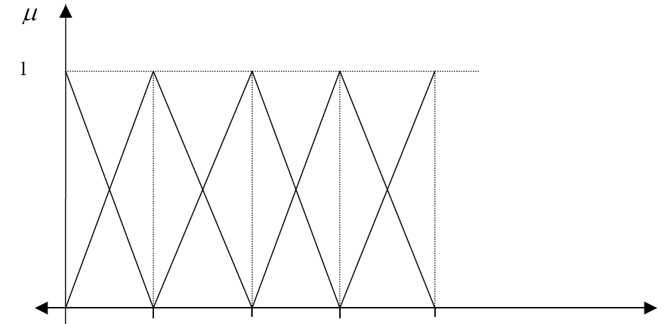

0 0.25 0.5 0.75 1.0

Figure 2: Graph of membership functions for Table 1.

Then, when evaluating the “market position of the brand” variable, a measure can be given of the gap with the objective, which is expressed by the distance between the language tag and the desired state of the variable. In the above example, according to the market surveys, the “market position of the brand” can be “poor”. On the other hand, the company’s expectations are for that variable to be considered “very good” by its clients. This situation is presented in Table 2.

Variable | E1 | E2 | E3 | E4 | E5
Service Quality | 0 |  |  | X

Table 2: Gap Measure between the variable and the objective.

Present value of the variable: 0
Objective value of the variable: X
Therefore, the present gap of the variable “market position of the brand” corresponds to the measure of the distance:
0
B = d (E1 , E4)
1

The graph corresponding to the definition of the gap between the present variable is shown in Figure 3.

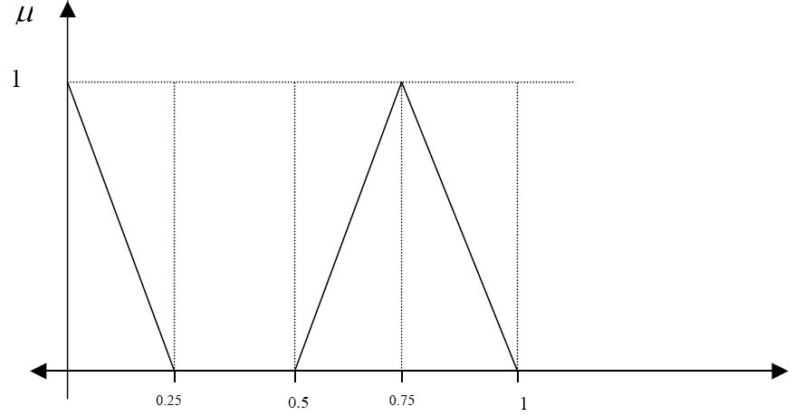
Figure 3: Graph corresponding to the variable’s gap.
In the case described in the graph of Figure 3 the measure of the gap for the “market position of the brand” variable is 1.375.

c) Confidence Intervals.
The confidence intervals can be applied when the set of the variables associated with the Critical Success Factors has been previously evaluated within each perspective of the BSC: financial perspective, client perspective, process perspective, and learning and growth perspective. The experts that participate in the construction of the strategic objectives associated with the four axes can express their opinion on the chosen variables through values belonging to an interval [0,1] that represents the degree of incidence of the variable in a predetermined incidence scale, as expressed in Table 3.

VALUE | DEGREE OF INCIDENCE
0.0 | Without Incidence (Nothing)
0.1 | Practically Without Incidence
0.2 | Almost Without Incidence
0.3 | Very Weak Incidence
0.4 | Weak Incidence
0.5 | Medium Incidence
0.6 | Sensitive Incidence
0.7 | Sufficient Incidence
0.8 | Strong Incidence
0.9 | Very Strong Incidence
1.0 | Total Incidence

Table 3: Incidence Scale.

1
Nothing very week medium Sufficient Strong Total
0
Figure 4: Incidence Graphic.

STRATEGIC MAPS AND FUZZY INCIDENCE MATRICES
Fuzzy incidence matrices can be used to represent the incidence of the various factors that participate in the connection of the different strategic objectives in the strategic map defined in each application. Its role is to collaborate in the validation of the cause-effect relations between objectives and between indicators. Fuzzy cognitive maps can be obtained from the opinion of one or several experts on the relations between some aspects of the evaluation process of a hypothetical case. The network of incidences of the critical success factors can also help to identify the importance of each of the variables that participate in the model through the Direct Incidence Matrix, DIM. For the model’s design a causal diagram or knowledge map is first introduced with a series of nodes that represent the concepts that are relevant to the system, and some connections between them that show the causal relation (influence) between concepts. Figure 4 shows the cause-effect relations model in a portion of a strategic map of a machine tool industry that delivers products on order, giving preference to customer satisfaction and loyalty, keeping the delivery dates of its products to its clients. Table 4 shows the critical success factors and indicators in three of the axes of the BSC strategic map.

CAUSE-EFFECT RELATIONS MODEL

Profitability
FINANCIAL AXIS

Customer Satisfaction
Customer Loyalty
CLIENT AXIS

On time delivery
INTERNAL PROCESSES AXIS

Figure 4: Cause-effect relations model.

N° | CRITICAL SUCCESS FACTOR | INDICATORS
1 | Profitability | ROI  ROE
2 | Customer satisfaction | Number of complaints/Total customers.  Customer score/Total score.
3 | Customer loyalty | Number of migrating customers/Total customers.  Customer’s degree of satisfaction.
4 | Product delivery time | Days of delay in delivery of products.

Table 4: Critical success factors and indicators on three BSC axes.

Then the Direct Incidence Matrix (DIM) is built with the help of the opinion of the experts and is expressed in Table 5.

DIM | 1 | 2 | 3 | 4
1 | 1 | 0.1 | 0.4 | 0.2
2 | 0.8 | 1 | 0.7 | 0.1
3 | 0.9 | 0.3 | 1 | 0.2
4 | 0.7 | 0.9 | 0.3 | 1

Table 5: Direct Incidence Matrix (DIM).

TECHNIQUE FOR THE RECOVERY OF INDIRECT EFFECTS
It is also possible to identify the indirect incidences between the critical success factors through the cause-effect relations between variables, in particular through the Technique for the Recovery of Indirect Effects, which makes it possible to identify the causes that act as intermediaries on the effects not taken into account by the Direct Incidence Matrix. From the DIM matrix it is possible to obtain the indirect effects that have greater incidence than those of direct incidence, calculating the algebraic DIM² – DIM difference. The Indirect Incidence Matrix, IIM, that is presented in Table 6 is obtained from the following equation:

DIM² = max [min {DIM, DIM}]

DIM² | 1 | 2 | 3 | 4
1 | 1 | 0.3 | 0.4 | 0.2
2 | 0.8 | 1 | 0.7 | 0.2
3 | 0.9 | 0.3 | 1 | 0.2
4 | 0.8 | 0.9 | 0.7 | 1

Table 6: DIM² Matrix.

IIM = DIM² – DIM

DIM² - DIM | 1 | 2 | 3 | 4
1 | 0 | 0.2 | 0 | 0
2 | 0 | 0 | 0 | 0.1
3 | 0 | 0 | 0 | 0
4 | 0.1 | 0 | 0.4 | 0

Table 7: Indirect Incidence Matrix IIM.

Values close to zero in the IIM matrix of Table 7 means that there is no indirect effect of a given Critical Success Factor on another, which means that the indirect effect can be caused by another factor. A value close to 1 means that the indirect incidence that one factor is exerting on another through a third one is greater than the incidence that may be exerted by that factor directly. Table 7 shows four factors that present that condition:
a) The case of Profitability over customer Satisfaction (0.2) in the IIM matrix, which is higher than that presented as a direct incidence (0.1) on the DIM matrix.

b) The case of Profitability over Customer Loyalty, whose incidence is 0.4 according to the experts and incides by 0.3 on Customer Satisfaction by calculating the indirect incidence, showing that Profitability has greater indirect incidence on Customer Satisfaction than what in principle it was expected to exert (0.3).

c) The case of Customer Satisfaction, which according to the opinion of experts incides with a value of 0.7 on Customer Loyalty, which in turn incides by 0.2 with respect to Timely Delivery, following the road of indirect incidence.

d) The case of Customer Satisfaction with respect to Timely Delivery, where the latter incides with a value of 0.9 on Customer Satisfaction, which in turn incides with a value of 0.8 on Profitability. It is seen that indirect incidence by this way is 0.8, higher by 0.1 than the incidence expected initially.

It should be noted that a high incidence index does not necessarily mean a high degree of causality between a critical success factor and another, since the phenomenon may have been caused by simultaneous improvements of the factors that are being considered.

DYNAMIC EVALUATION OF THE BSC USING FUZZY INTERVAL KNOWLEDGE BASE MATRIX
In the dynamic evaluation of the BSC each of the concepts of the strategic map will be a fuzzy set. The connections between concepts will have an associated value in the [-1,1] range that represents the degree of causality (influence) of one node on another. If the value is positive, it indicates that an increase of the evidence of the concept of origin increases the meaning, the evidence or the truth value of the target concept. If it is negative, an increase of the evidence of the source decreases that of the destination. If the value is 0 there is no connection, and therefore they are concepts with no causal relation. On the other hand, internally each subsystem can be represented by Fuzzy Interval Knowledge Base Matrices (Cordova et al, 2010), allowing their incidence weight or relative cardinality with respect to other subsystems, and in turn represent its particular behavior, as shown in Table 8, where it is possible to identify the indirect incidences among the critical success factors.

CHARACTERISTICS OF SUBSYSTEM 1 | ATTRIBUTES (Metrics or fuzzy functions)
Fuzzy Functions
FACTORS 1 | Rel.Card.  (CRC) | 1 | 2 | 3 | 4 | .. | .. | .. | .. | i
1. Profitability |  | µ₁₁ | µ₁₂ | µ₁₃ | µ₁₄ |  |  |  |  | µ_{1j}
2. Customer Satisfaction |  | .
3. Customer Loyalty |  | .
4. Product Delivery Time |  | .
i. |  | µ_{j1} | µ_{j2} | µ_{j3} | µ_{j4} |  |  |  |  | µ_{ii}
Relative Cardinality of Subsystem (CRS1).

Table 8: Relevant Subsystem Characteristics.
In Table 8, µ_{11,,…,}µ_{ij} are membership functions associated with each critical success factor. The example presented can be generalized to different cases of the subsystems mentioned above, and we point out that this case constitutes only a node of the system at a higher level of abstraction, a system in which the connectives are fuzzy membership functions and to each node or subsystem must be assigned the factors, with their respective associated weights, by means of which the importance of that node within the total system will be determined.

CONCLUSIONS
The use of imprecise definitions in the design of the BSC by experts justifies the use of fuzzy variables, fuzzy membership functions, fuzzy language tags, and fuzzy confidence functions in this process. On the other hand, the strategic map can be expressed through a conceptual map of fuzzy causal relations where the Fuzzy Incidence Matrices offer a great contribution to the analysis, when they are used to represent the incidence of the various factors that participate in the connection of the different strategic objectives on that map. On the other hand, the Indirect Incidence Matrix allows the detection of errors in the evaluation of direct influences perceived by the experts when evaluating the Critical Success factors in the definition of the strategic objectives and indicators of the strategic BSC map. This analysis allows the experts to review the criteria that they applied in the evaluation of the matrix and improve the process of decision making and of application of the strategies in various scenarios. They will also have a definition of the critical success factors that have a greater incidence over others. Finally, the use of the Fuzzy Interval Knowledge Base Matrices allows the dynamic evaluation of the BSC, going deeper in the analysis of indirect incidences of strategies, strategic objectives, action plans, and indicators defined in the BSC.

REFERENCES
Cordova, F.M., Leyton, G. 2010. A Fuzzy Control Heuristic Applied to Non-linear Dynamic System Using a Fuzzy Knowledge Representation. International Journal of Computers, Communications & Control, ISSN 1841-9836, E-ISSN 1841-9844, Vol. V (2010), No. 5, pp. 661-661.
Cordova F., Quezada L. 2008. From Natural Language to Soft Computing: New Paradigms in Artificial Intelligence (Chapter), Lotfi A. Zadeh, Dan Tufis, Florin Gheorghe Filip, Ioan Dzitac (Eds.), Editing House of Romanian Academy.
Kaplan, R., Norton, D. 2003. Putting the Balanced Scorecard to Work. Harvard Business Review, pp. 134-147.
Kaplan, R., Norton, D. 1996. Using the Balanced Scorecard as a strategic Management System. Harvard Business Review, Vol. 74, Nº 1, pp 75-85.
Kaplan, R., Norton, D. 1996. Linking the Balanced Scorecard to Strategy. California Management Review, Vol. 39, nº 1, pp. 53-79.
Kaplan, R., Norton, D. 2000. Having trouble with your strategy?: Then map it. Harvard Business Review.
Kaplan, R., Norton, D. 2004. Strategy Maps: Converting Intangible Assets into Tangible Outcomes. Harvard Business School Press. Boston. MA. USA.
Kaplan, R., Norton, D. 2006. Alignment: Using the Balanced Scorecard to Create Corporate Synergies. Harvard Business School Press. Boston. MA. USA.
Silder, W., Buckley, J. 2005. Fuzzy expert system and fuzzy reasoning. John Wiley and Sons Inc., New Jersey, 416.
Zadeh, L.A., Fu, K.S., Tanaka, K., Shimura, M. 1975. Fuzzy Sets and Their Applications to Cognitive and Decision Processed. Academic Press, New York.
Zadeh, L.A. 1985. The role of fuzzy logic in the Management of uncertainly in Expert Systems, Approximate Reasoning in Expert Systems, Elsevier Science Pub., North Holland, 3-31.
Zadeh L.A. et al (eds.). 2008. From Natural Language to Soft Computing: New Paradigms in Artificial Intelligence, Editing House of Romanian Academy.

